A Project Report
On
Natural Language Processing for the classification of the severity of road
accidents from Social Media

BY
NAME | ID NO.
Harshal Bhambhani | 2022A3PS1809H

Under the supervision of
PROF. BANDHAN MAJUMDAR

SUBMITTED IN THE FULLFILLMENT OF THE REQUIREMENTS OF
EEE F376: DESIGN PROJECT



BIRLA INSTITUTE OF TECHNOLOGY AND SCIENCE PILANI (RAJASTHAN)
HYDERABAD CAMPUS
(JAN 2025)

ACKNOWLEDGMENTS
I am deeply grateful to the Electrical and Electronics Department at BITS Pilani,
Hyderabad Campus for offering a solid academic foundation and invaluable
resources that significantly contributed to the partial completion of my project.
I would also like to express my heartfelt thanks to my project mentor,
Prof. Bandhan Majumdar, whose guidance, support, and insightful feedback is
instrumental in shaping the project and ensuring its progress.


Birla Institute of Technology and Science-Pilani,
Hyderabad Campus

Certificate

This is to certify that the project report entitled
“Natural Language Processing for the classification of the severity of road
accidents from Social Media”

Submitted by Mr. Harshal Bhambhani (ID No. 2022A3PS1809H) in the fulfillment of the requirements of the course EEE F376, Design Project Course, embodies the work done by him under my supervision and guidance.

Date: 01.05.25 (PROF. BANDHAN MAJUMDAR)
BITS- Pilani, Hyderabad Campus

CONTENTS

Title page……………………………………………………………….1
Acknowledgements……………………………………………………..2
Certificate…………………………………………………………….....3
1.Introduction…………………………………………….………….....5
2.Previewing Literature…………….…………………………………..6
3 Exploring Alternatives to Twitter ……..…………………………….8
4. Problems with Twitter APIs ……………………………………...…9
5. Twitter Scraping (Initial Progress)………………………………….11.
6. YouTube comments Scraping……………………………………….12
7. Exploring the scope of YouTube Scraping…………………………..15
8. Switching over to News Article Scraping…………………………16
9. Advantages of News Article Scraping over others…………………18
Conclusion……………………………………………………………..19
References……………………………………………………………..20

NEED FOR STUDY

Road safety is an alarming global concern, with millions of fatalities occurring annually, leading to severe injuries and even deaths. Traditional forms of media reporting on road safety often lack real time public sentiments and often suffers from delays in reporting. However, the use of social media platforms such as Twitter, Facebook, and Reddit has introduced a new platform for gathering immediate information about road accidents and public opinions. Artificial Intelligence (AI) and Natural Language Processing (NLP) offer useful tools to analyze unstructured and unrefined data, enabling real-time accident detection and understanding of public sentiment towards road safety policies and incidents. By implementing AI-based sentiment analysis, public can assess the general perception of road safety measures, identifying high-risk locations, and predicting accident trends based on time, location, and contributing factors such as speeding or poor infrastructure. NLP techniques such as text classification and sentiment analysis allow for the filtering and categorization of social media posts. Moreover, AI-driven real-time analysis can assist emergency response teams in reacting briskly to severe accidents, potentially reducing fatalities by improving response times. The findings from such analyses can be of significant public value, helping authorities and researchers to develop proactive measures for accident prevention and improved traffic management.

PREVIEWING LITERATURE

Given is the summary of the research papers provided.
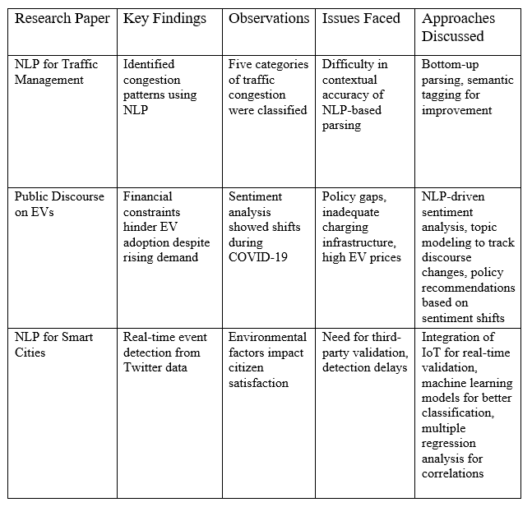

Summary of relevant research papers collected based on Twitter Scraping, Sentiment Analysis and other NLP techniques.
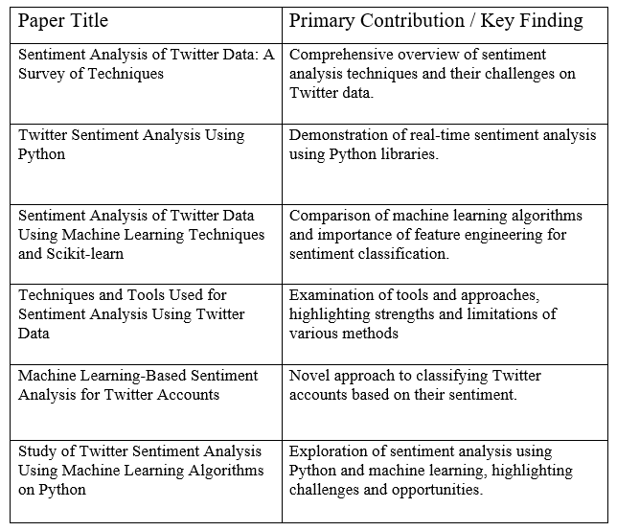
EXPLORING ALTERNATIVES

- Online News Outlets
Online news portals can serve as a reliable option for accident data collection and analysis. Twitter provides real-time information by the public, news sources offer verified reports. Using online news for analysing two-wheeler road accidents can be often useful when real-time data is not required.
Challenges with Online News
a) Slower Updates: News articles are published after authentication, resulting in a delay compared to the dynamic nature of tweets.
b) Limited Coverage: Minor accidents may not be reported
c) Paywalls and Access Restrictions: Good-quality news sources are usually behind paywalls, which hinders data collection.

- Other Social media platforms
Platforms like Facebook, Reddit, etc are not a viable option either because of lack of relevance, reducing popularity among the masses while Twitter offers
- Geo-tagging
- Public tweets
- Hashtags for awareness
- Developer friendly APIs
- Engagement Matrix such as retweets and likes

PROBLEMS ENCOUNTERED
- Accessibility of Geotags:
Not all users activate geotags, so dependency on this data can limit dataset.

- Uncertainty in Textual Context:
Locations mentioned in tweets can be often colloquial (e.g., "near the mall")

- Noise in Data:
False positive tweets may arise if locations are mentioned in an unrelated context.

- Multi-language Tweets:
Tweets in regional languages require advanced multilingual NLP models to tokenize tweets or keywords.

- Change in legalities:
Post 2023, Twitter has changed its policies restricting API and data collection more challenging.

WORKFLOW
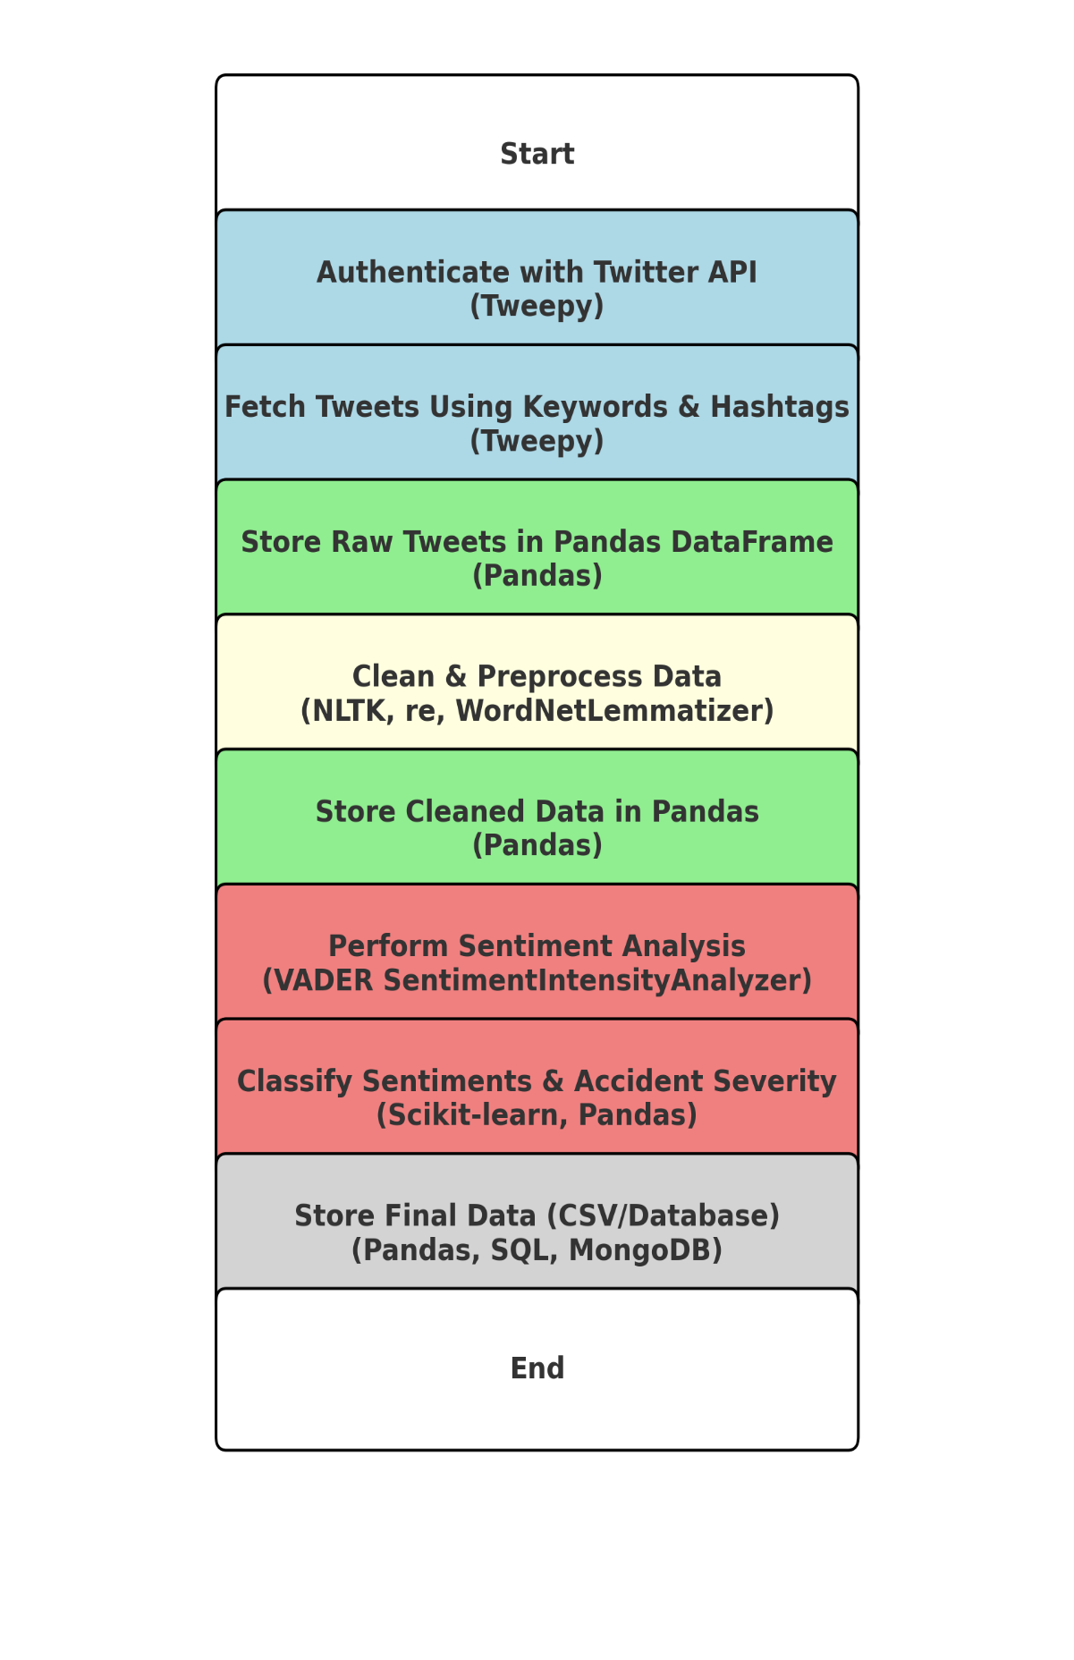

TWITTER SCRAPING : INITIAL PROGRESS
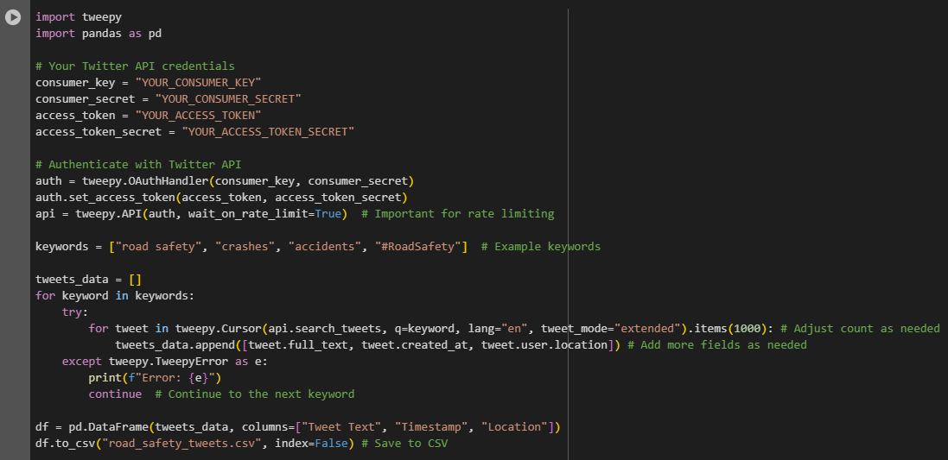
We start off by using the tweepy library to access the twitter API by using our credentials to the twitter developer account.
then we store the retrieved tweets in a structured format, such as a Pandas DataFrame.

YOUTUBE COMMENTS SCRAPING

While finding the turnarounds we initially ideated to use YouTube comments as a replacement of tweets because of the dynamic and sentimental nature of comments under concerned videos.
We scrapped YouTube comments to identify road safety-related keywords like accidents, death, fatal, safe, etc. especially in Hyderabad.

We generated a free YouTube Data API key by creating a project in the Google Cloud Console (https://console.cloud.google.com/) and enabling the YouTube Data API v3.

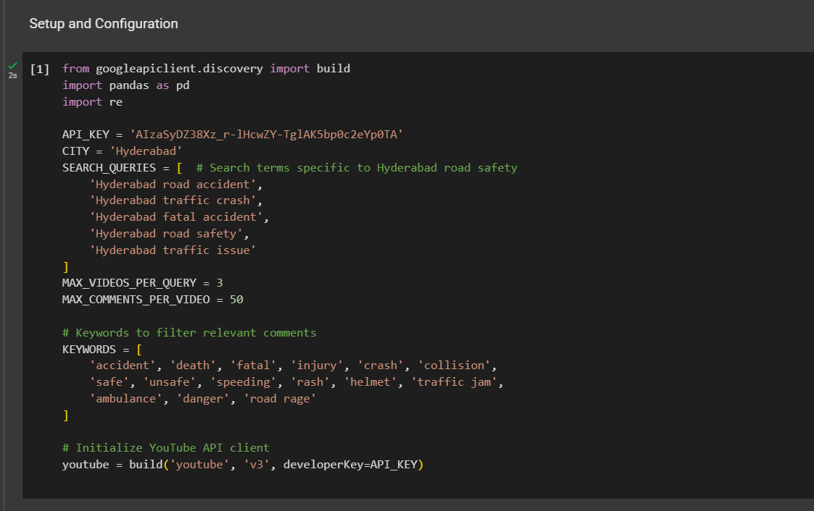
Here are the code snippets.

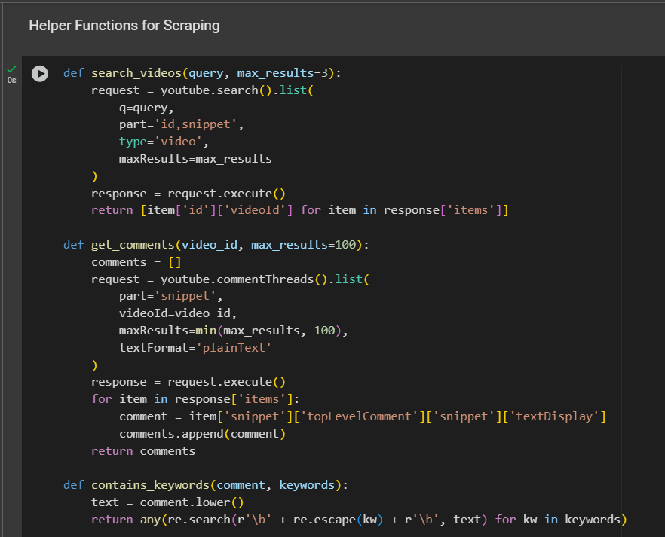
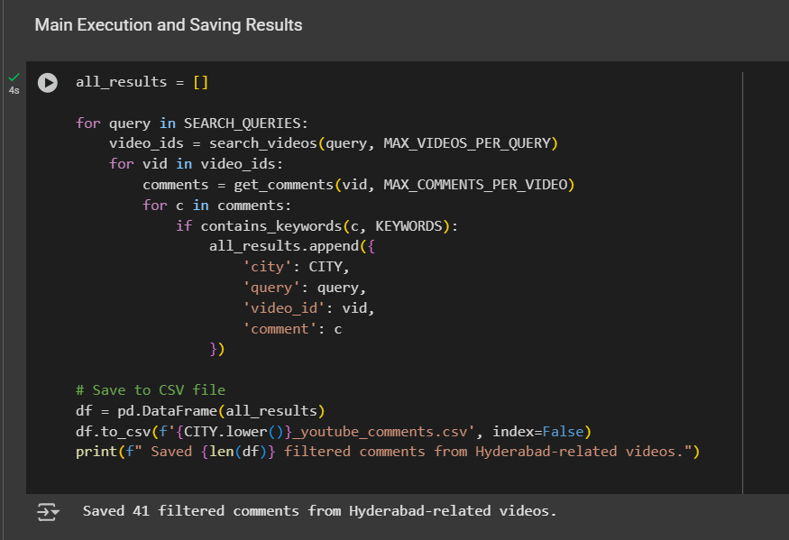

RESULTS
The resultant csv file consisted of the scraped YouTube comments with queries and the relevant information with respect to the keywords in the database along with their video id is attached below.
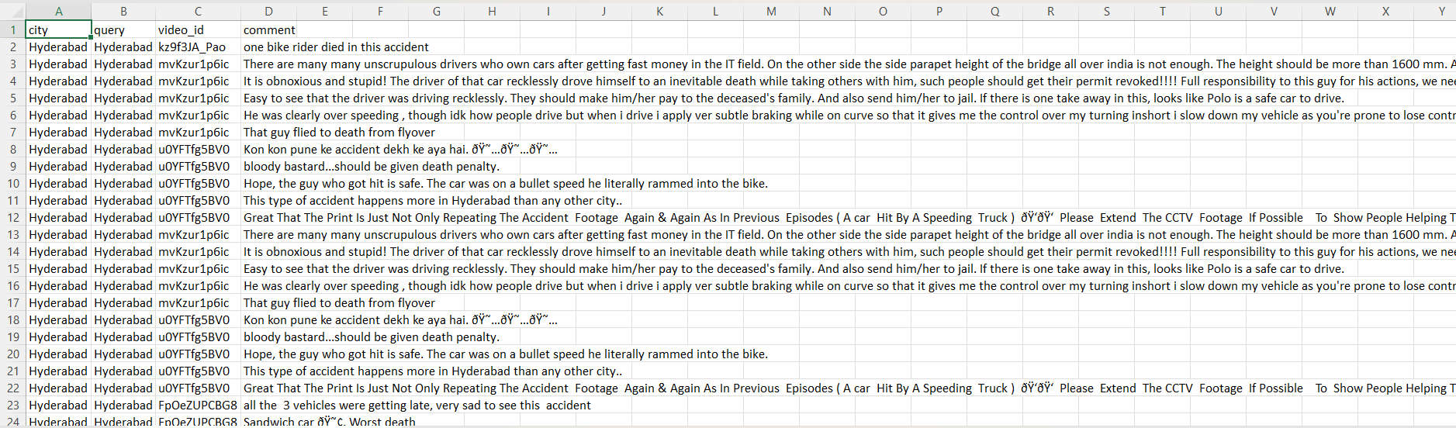

EXPLORING THE SCOPE OF YOUTUBE SCRAPING

Scraping YouTube comments using the YouTube Data API presents several challenges:
- Limited Tokens:
The limit on daily tokens of 10,000 units/day, where searching videos costs 100 units and each comment thread costs 1 unit hinders the possibility of scraping a larger dataset.

- Language & Spelling Variations:
Comments may include Hindi, Telugu, or regional spellings/slang (e.g., "aksident", "raod saftee") that basic keyword filters won’t catch. Thus multilingual keywords will not be recorded by the data scraper.

- No Geo-Filtering in Comments:
YouTube doesn’t provide geolocation for comments, so you can’t confirm if a commenter is from Hyderabad—only the video query is region-based. The lack of this key information invalidates the relevance of the data scraped since there is no way to verify this.

Switching over to News Articles for Sentiment Analysis

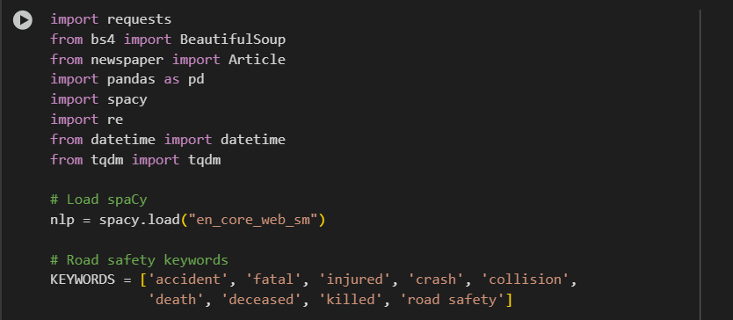

` 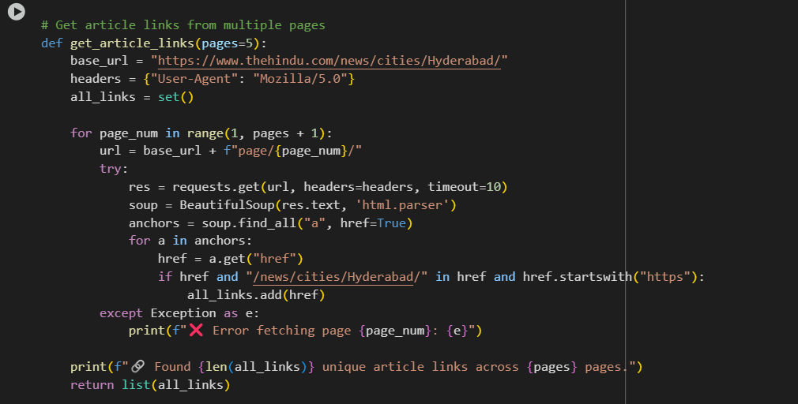

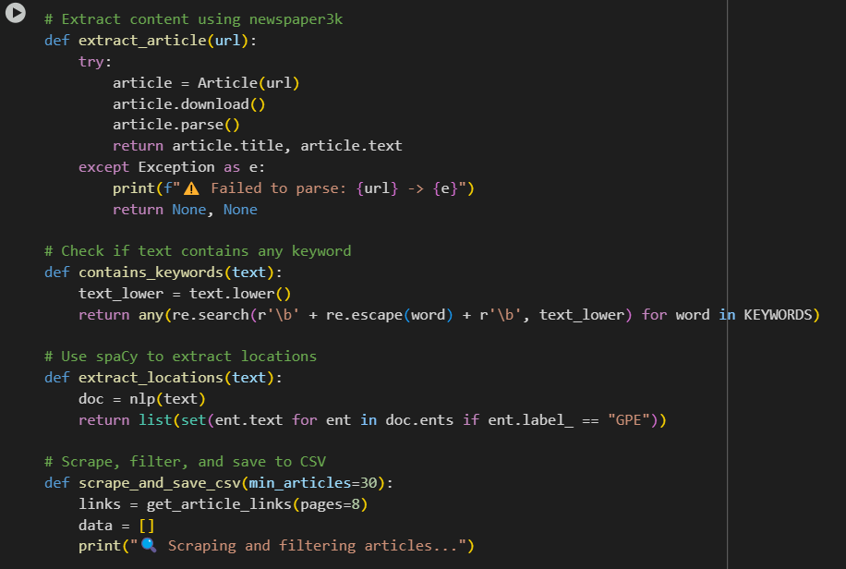

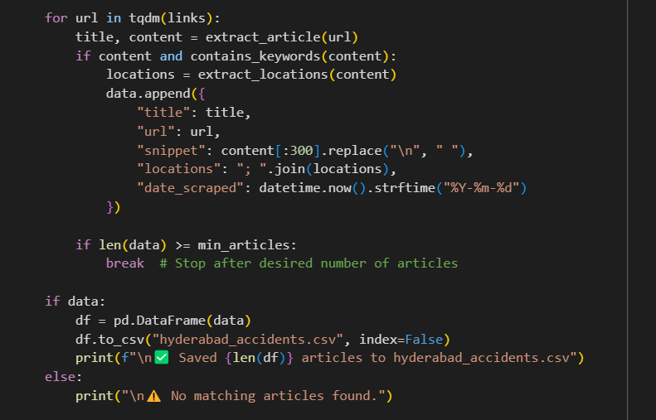
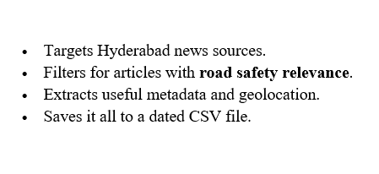
Advantages of News articles for data extraction over the others:
1. Officially verified and cross-referenced information:
- News content is usually fact-checked, edited, and follows ethical guidelines.
- Less noise or false claims compared to social media platforms.

2. Structured and Context-Rich Language:
- Journalistic writing tends to be well-structured, making it easier for NLP tools to parse and extract:
  - Events
  - Entities (e.g., locations, people)
  - Cause-effect relationships (e.g., "over speeding caused the accident")

3. Detailed information regarding the events:
- Articles often include dates, locations, victim identities, statistics, and official statements.

4. Historical and Longitudinal Value
- News articles span years, so it helps in observing the trends spanning over a longer period of time.
E.g., sentiment changes after policy announcements, helmet laws, etc.

5. Geographical Relevance
- Local publications (like Deccan Chronicle, The Hindu) focus on specific cities/regions like Hyderabad.
- Easier to map sentiment to specific geographies or road zones.

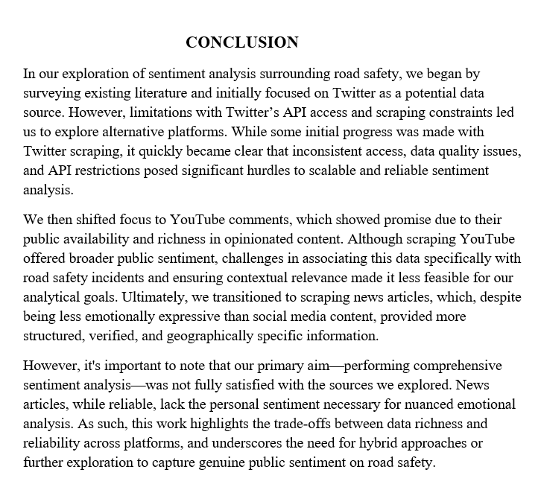

REFERENCES
- https://journals.sagepub.com/doi/10.1177/1748006X221140196
- https://www.researchgate.net/publication/323786037_Incident_Detection_Using_Data_from_Social_Media
- https://www.mdpi.com/2078-2489/13/1/26
- https://ieeexplore.ieee.org/document/8317967/
- https://www.mdpi.com/2624-8921/7/1/5
- https://www.researchgate.net/publication/390806678
- https://arxiv.org/pdf/2504.21025
- https://pmc.ncbi.nlm.nih.gov/articles/PMC9482885/

